Names: groupe2.
Zarifi mohamed abd elhadi.
Sadoune fadjr.
The explanation of the game and the program

hello there I know you got a bit confused after you saw the code source of this game but don’t worry i will explain every thing the best way I can
first we are going to go to the game rules
1.in the start of the game we were asked to put numbers from 1 to 25 in a matrix of 5*5 place without repetition well for that I used the boolean algebra logic to put numbers in table using rand
here is the code:
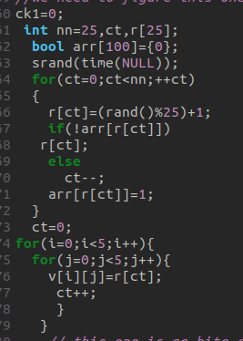

first I put this r[ct]=(rand()25%)+1) so it generate random numbers and put them in the table and then the table get into loop and start to compare that number to the other’s inside using a declared boolean table arr[] when ever it find it equal to another one it minimize the value of ct by a and do it again so on until the number’s from 1 to 25 are at a random placement in the table with no repetition then when it finish it copies everything in that table to the matrix v[][] using two loops and ct++.

2.the player and the pc are not allowed to win by the numbers that are Somme of more than one range in the start of the game the source code to detect them is divided to four spots:
1.
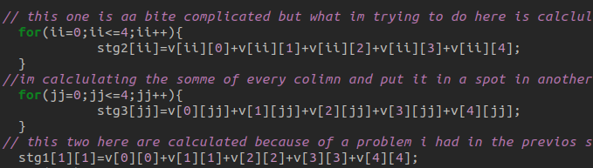

this one is to calculate the value of the lines, columns and the diagonal we will see more of this as we progress in he code.
2.
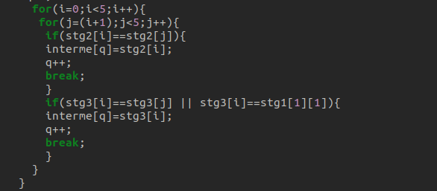
in this one I choose to loop with condition so I start to loop from 0 to 4 because using I variable.
and the second one I used the for loop and the j variable and I put it equal to i+1 so that when I have the same number twice in the line or the column of the value It’s easier to not repeat number two times it when we declare in the interface
if stg2[i]==stg2[j] this is the comparison part if it’s right the value of stg2[i] will be stored in another variable called interme[] that and q++ is used to when ever one value stored in a spot in the table the q++ will change to another spot to not whip any value out
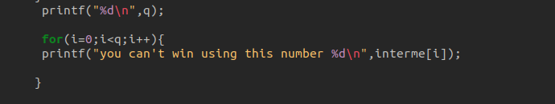
3.

now we declare what we stored in this table as an illegal numbers to win by.
as an example:
in this example we can see that the number 69 is reputed in two places so no one can win using it..
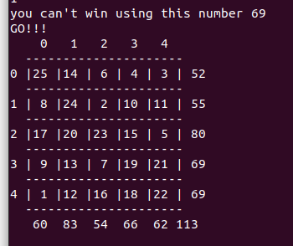

and if we try to win with it we won’t win.
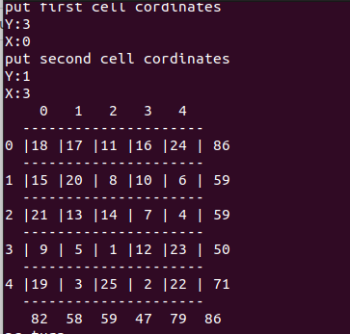
Example :
here we tried to win using 59 but as you can see the game didn’t stop so we didn’t win.

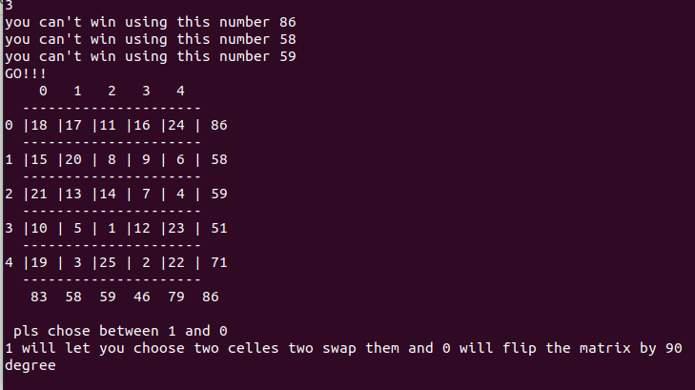

3.the numbers have to be visible so we used that 5*5 matrix so we did that
the code source:
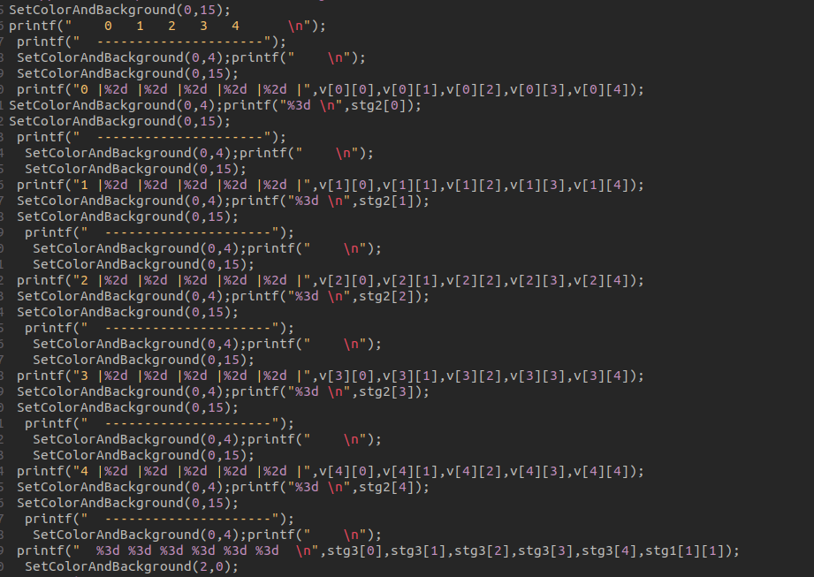
for the colors I used windows.h library and this function:
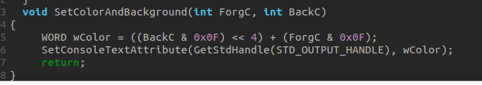
to use it we declare the function in the places we want to use it in
the function declaration number :

the colors numbers we used:
red:4.
black:0.
white:15.
Green:2.
and we fulfilled your request on making the matrix of random numbers and the value line and column in two different colors.
As an example is the matrix interface which I used a lot this functions the result is this beautiful graphic interface for the matrix :

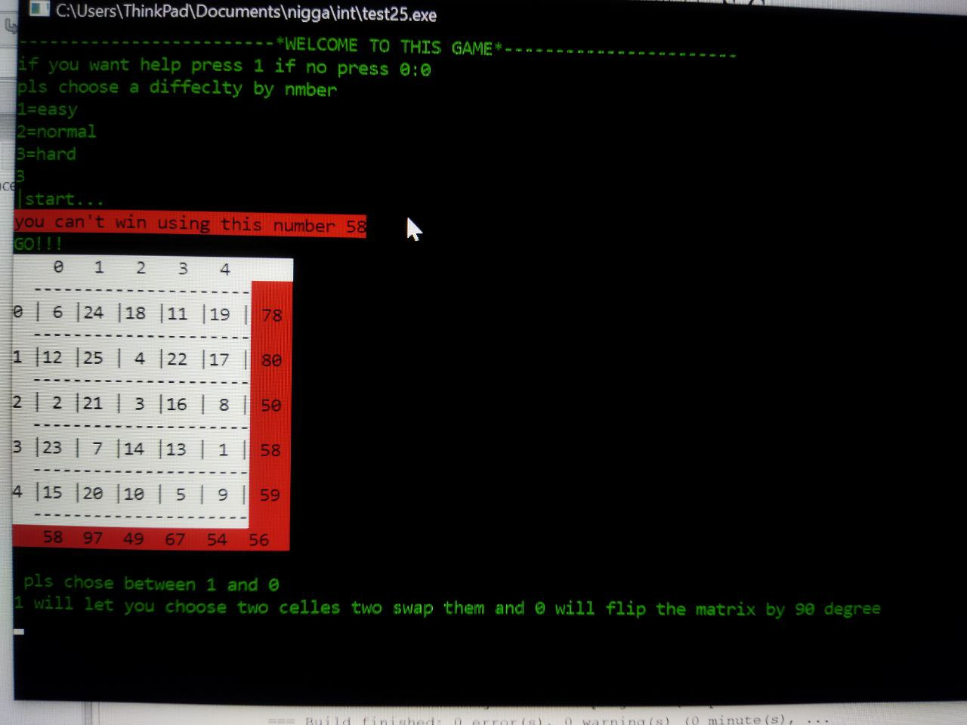

the rest execution is without colors as we progress in the explanation because I was working with Linux and windows.h don’t work on it.
the idea is making it like an excel sheet and we did the work by a matrix called (v) and this tables (stg2),(stg3)+ this mini matrix (stg1) were added to not have a hard time calculate the some of every one and
the source code:
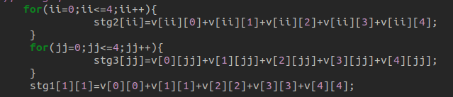

i,ii,j,jj are mostly used for loops.
stg2 is for lines.
sg3 is for colones.
stg1 is for diagonal.

4.the player and the pc are allowed to choose between two moves one is to flip the matrix by 90 degree , choose between two numbers in the matrix and switch between their places for this one I used a function with pointers. Source code:
I used basic understanding of the pointers to create two swap functions
the first is used to swap between two values the second was created for a specified function .
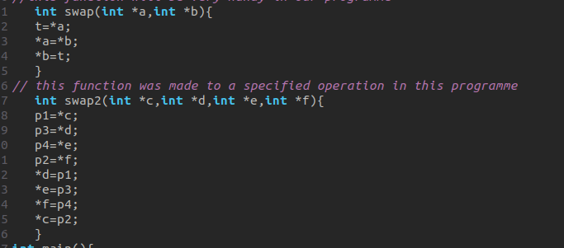
The function is to store the address of the variables of a certain line or column before the other line or column takes their place when the function and the stored address will be ready to the the same thing and so on until the matrix fully flipped the example shows how it will be done.

now back to the game when the player or the pc choose number 0
the program will flip by 90 degree.
the source code and the example:
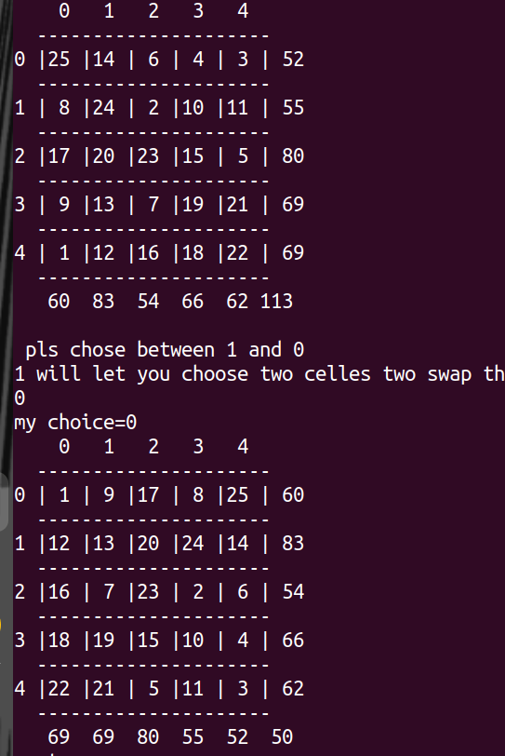
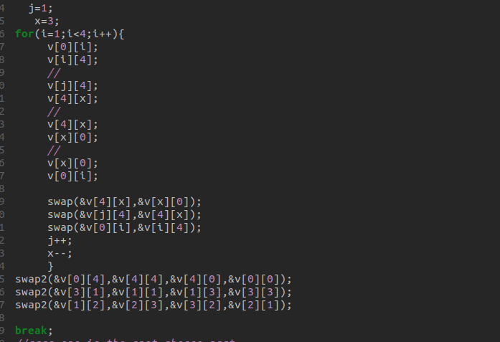

to explain this we will look at the example up in the left.
in the code source you can see that I put a road map using loops and variables like x and j to keep the order right x=3 and j=1 so that the 90 degree flip happen in between the edges because I had problem adding the edges there that is why swap2 was created.
The edges flip by swap2 and what is between the flip by swap .

Now for the second choice which was quite simple to make
code source:

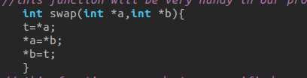
player choose the coordinates and the program execute
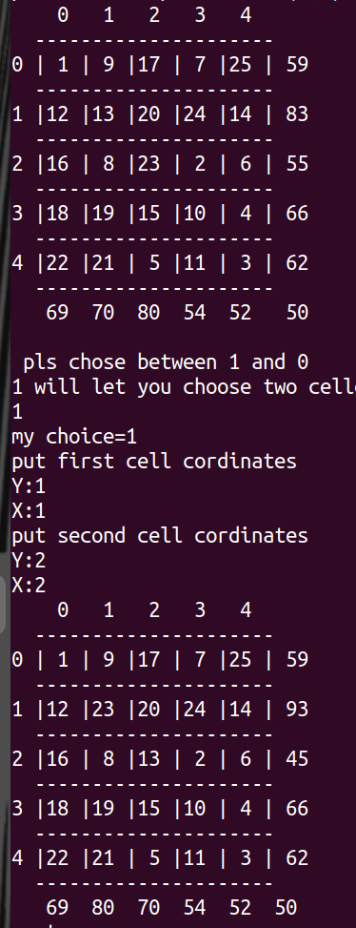
example:

.you have got to be extra careful using coordinates because you may miss and if you do you can put the number in one of the inputs out of range It will automatically reset and tell you to start over so you can use it incase you miss the number you want to swap.
Here is the source code of this :
I made a change in print : X and Y the example before the change was made.
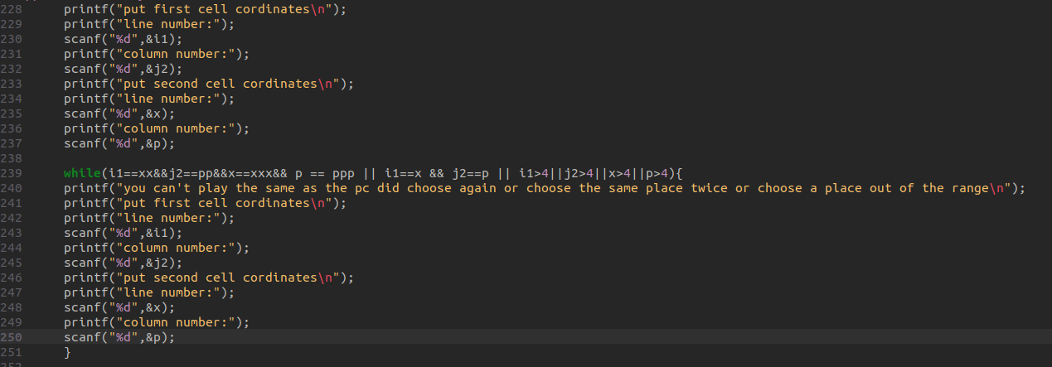
this code is used to stop you from choosing the wrong spot or the same spot twice or the same as the pc did in the previous turn using an if statement an a while loop .

6.if the pc choose to flip 90 degree the player can’t and the other way around and if the pc choose to switch between two number the player can’t choose the same two number’s and the other way around.
The source code for those two moves:
the switch between two numbers:
For the player:
i1 and j2 are the player first cell coordinates variables
x and p are the player second coordinates variables.
xx and pp are the pc first cell coordinates variables
xxx and ppp are the pc second coordinates variables.
I used a while loop so if all of this variables get equal to each other the way I put them in the while loop you won’t be able to play them and you will be forced to another ones at least one of them is different.
For the pc:
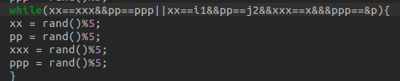
the same logic as mine the deference is that the variables of the pc choice are first.
The 90 degree flip:
for the player:
if the pc choose to flip the player will be forced to choose to second choice same goes
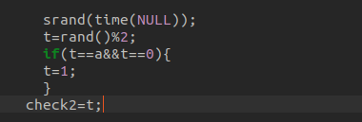
for the pc:

.now for the game play of the pc and how he do the two numbers swap:
the pc do random moves using the rand function in a controlled range fist he choose the two cells y rand()%5 in condition of not choosing the same place I choose before him and than the swap function do the action:
code source:
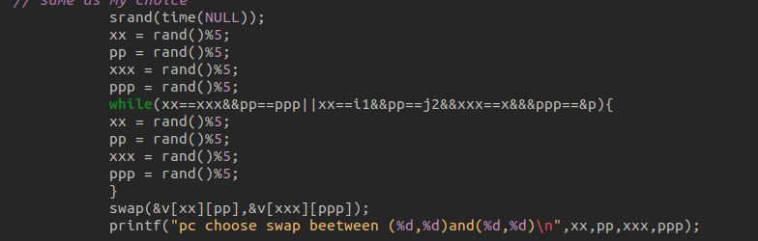
an example:
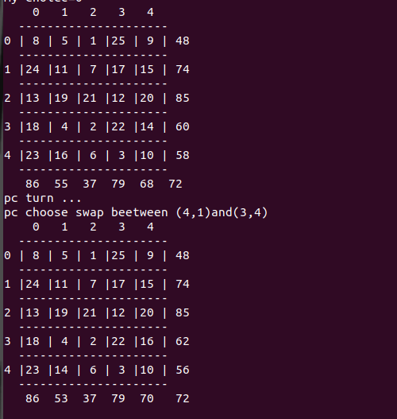
now for the logic of the game:
to win this game there three options if you do one of them you win .
1.to achieve the same some in three lines
2.to achieve the same some in two line and one column
3.to achieve the same some in two lines and a diagonal
for that I wrote three conditions:
first 1 code source for option 1 :
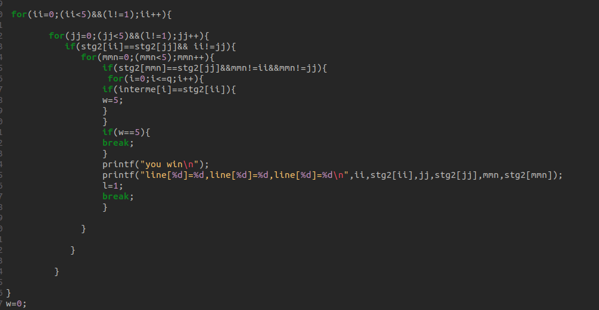
I wrote a program that compare every line with two others and if the conditions match you win
first for loop was for the lines we compare to
and the other two were for the two lines
between every two loops a condition which if it was right the other loop will start working until it reach the final loop and if we indeed have three lines values equal to each other you win .

and as an assurance that the program will work as it should be I added a last loop for the illegal numbers table so if the stg2[ii] which is the the some of the line match one of the illegal table numbers it break before it say you win until stg2[ii] is not equal to any of the illegal numbers.

Example:
the pc use the same logic as me so it’s okay to put an example from it and because it’s much faster to get the results with the smart pc difficulty because he calculate so much faster.
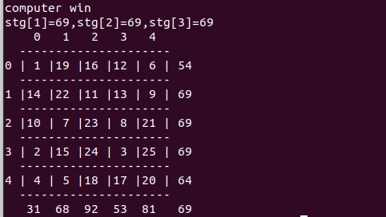

Second option code source :
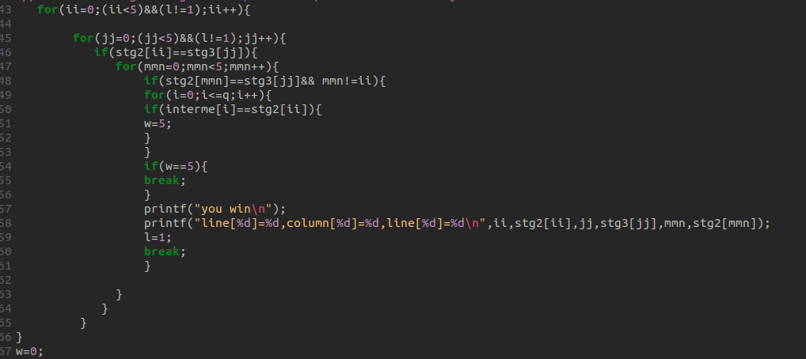
the same explanation as the first just this one use the column in jj loop stg3[jj].

Example for this code:

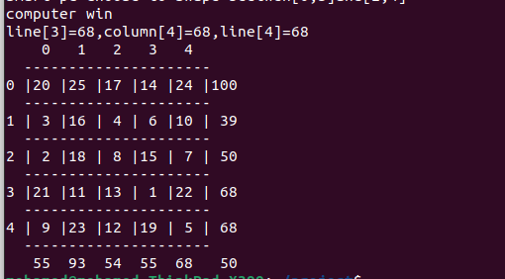

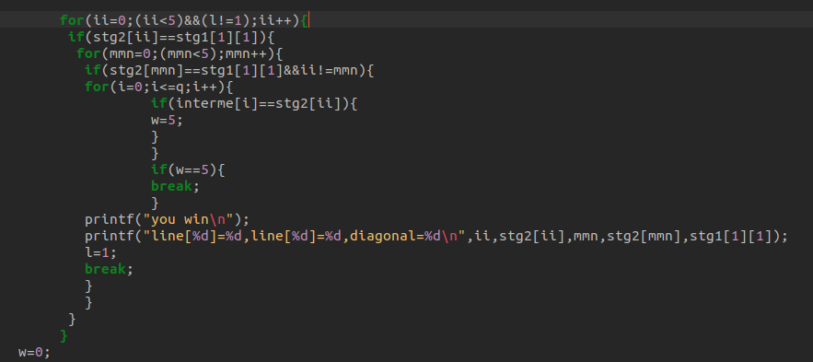
third option source code:

the same here too but with only the lines have a loop because the diagonal is only one so I just put it in the conditions.
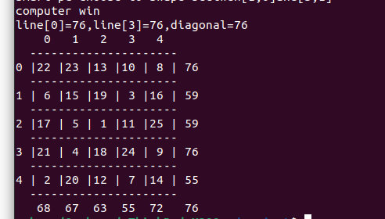
Example for this code:

Since the pc use the same logic the only difference that the pc part print computer win so no need to explain the same thing twice.

now we are done with the standard game logic:
time to go for the excellent point.

Now for the difficulty :
in this stages I used a method I was using my self to win the pc I made it into several programs under two major conditions depending on the case of winning that is possible and without using the illegal values.
On paper here is my method:

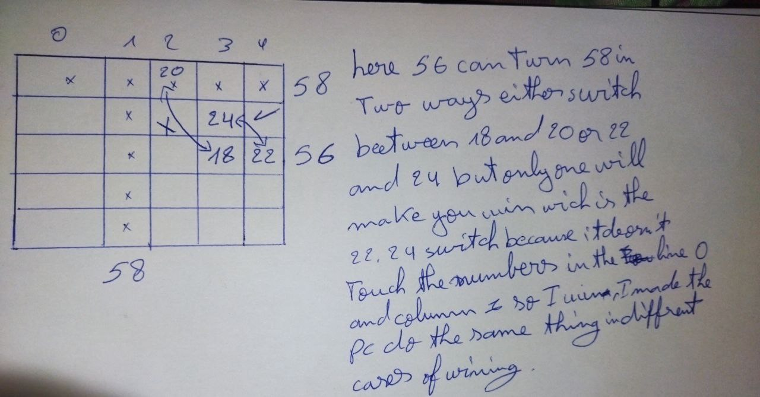

explanation on how the pc will use this method to play and the code source of one of the cases:
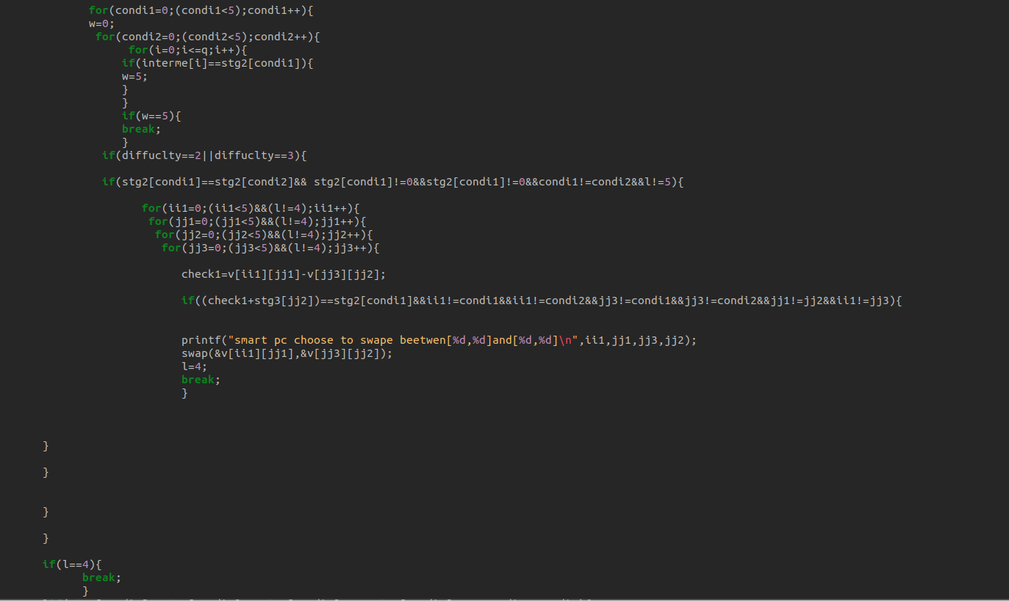
just like the winning program work you got the first loop using condi1 as a reference to condition one this one was put to detect the value of the first line in comparison and then you got the second loop condi 2 that detect the second line value for the now in this case we are trying to get line line column win
so we have an if statement that is the condition
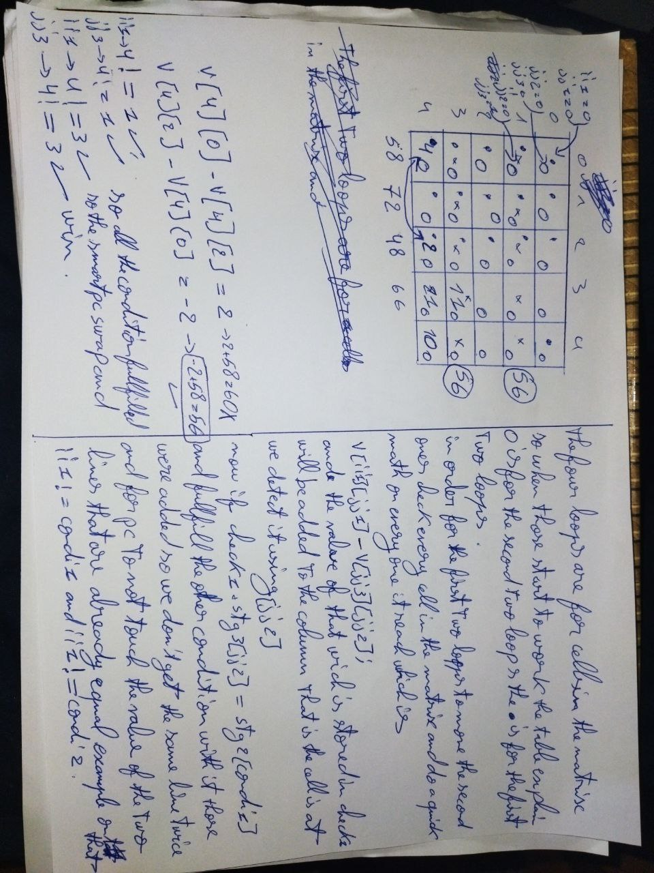
in case that stg2[condi1] = stg2[condi2] and condi1 != condi2 means we have two lines with same value then the condition if fulfilled and the program will enter the second part of the program which is the comparison between cells here is how it works on paper:

as for the other cases it will be the same explanation the only difference is if it’s a column or a third line of a diagonal .
It was done in both ways so let’s say you got two lines but there’s no possible column to win and there's only a diagonal the pc will detect it and swap
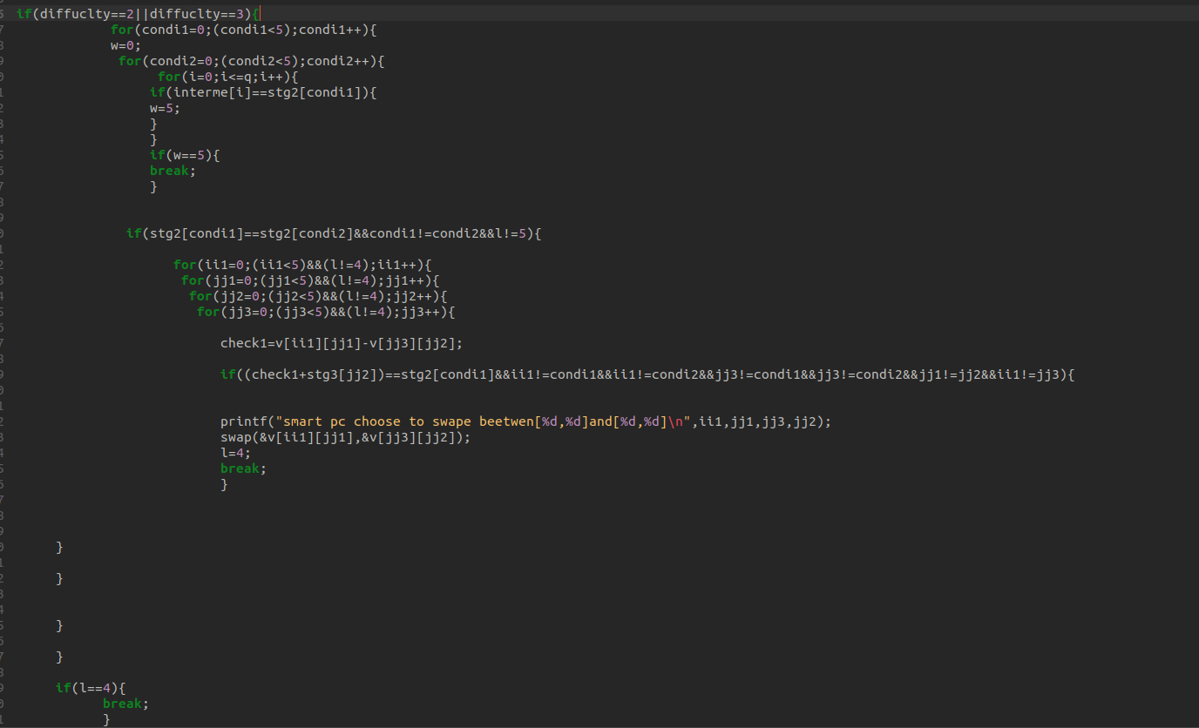
or there is a column and one line so you only need a second line pc will detect it and swap and win and another thing which is that I put a loop to compare between the table of illegal values and stg2[condi1] so it can’t win using them etc…
here the conditions source codes:
the line line column:

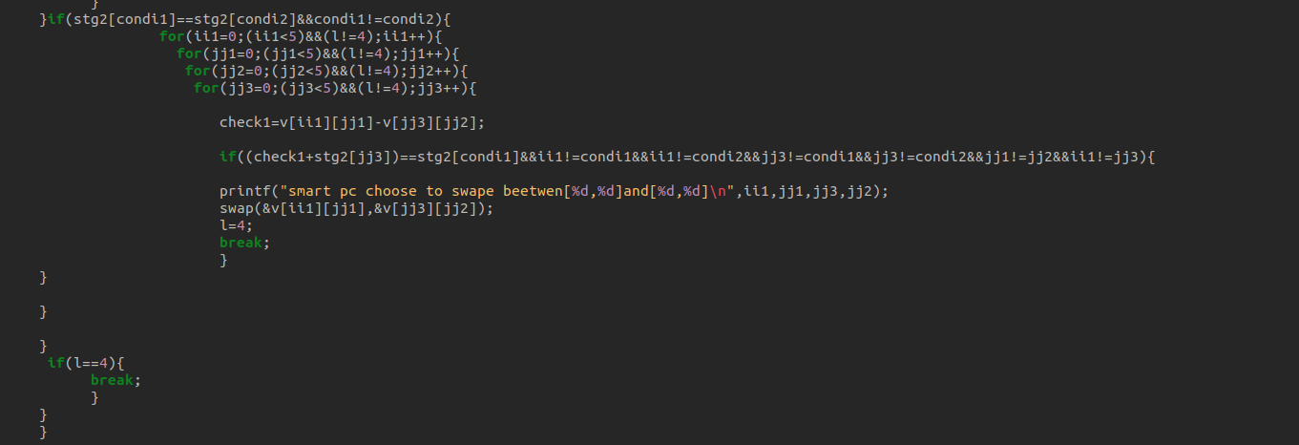
the line line line:

the line column line:
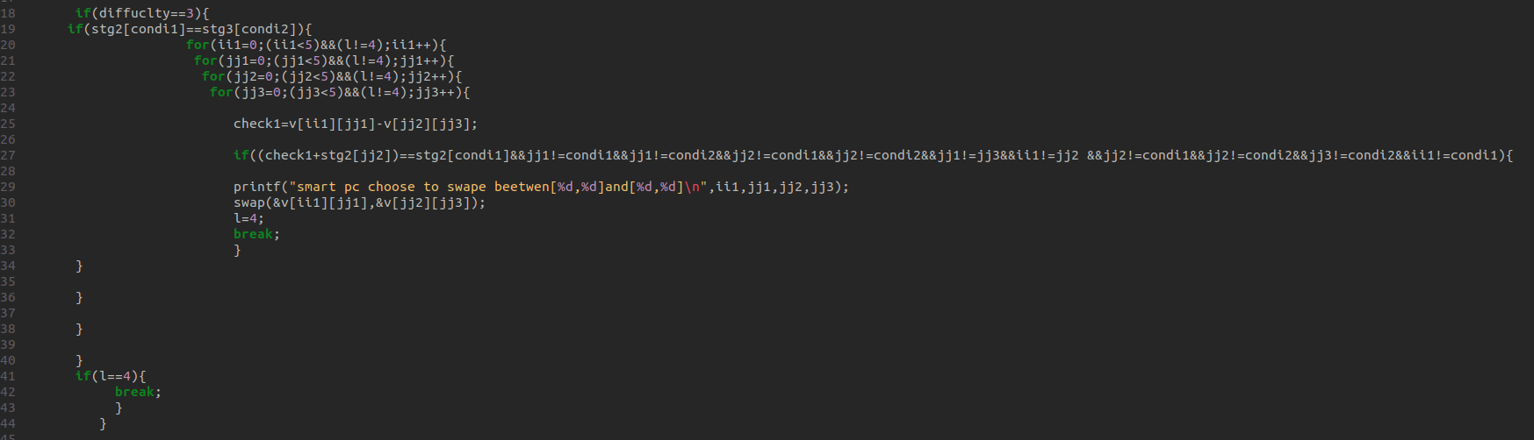
the line diagonal line:
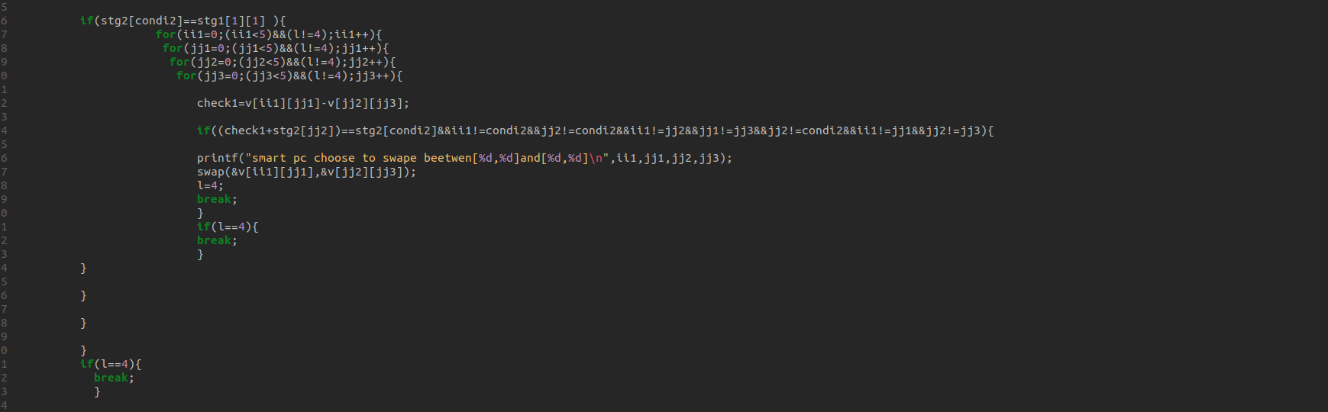
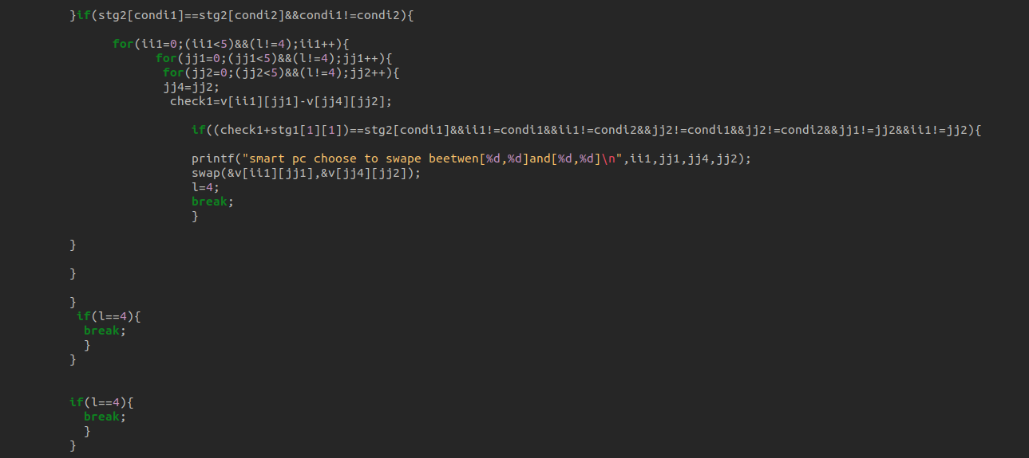
the line line diagonal:

I put an if statements to choose the difficulty
1easier the pc will play randomly.
2normal the pc will use the line line column and the line line line programs.
3the hard will use them all.
.
the rest of the code is explained in the comments.
Thanks for reading this essay.
enjoy playing the game.

